Title: Software Development Project use case diagram

Name: Mark Ngugi.

Reg.No: Sccj/00645/2021. Date: 27/04/2023.

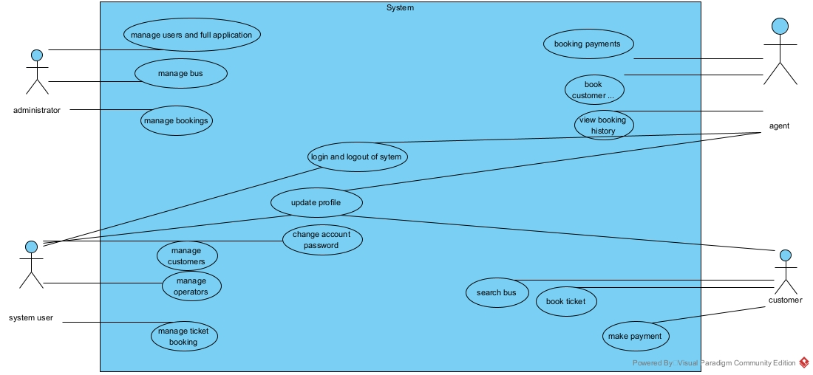

1